Terraform task 2
1). Execute all the templates shown in the video.
File: main.tf
Purpose: main.tf contains the actual infrastructure resources that Terraform needs
to create, modify, or delete.
Command: $ terraform init, $ terraform fmt, $ terraform apply
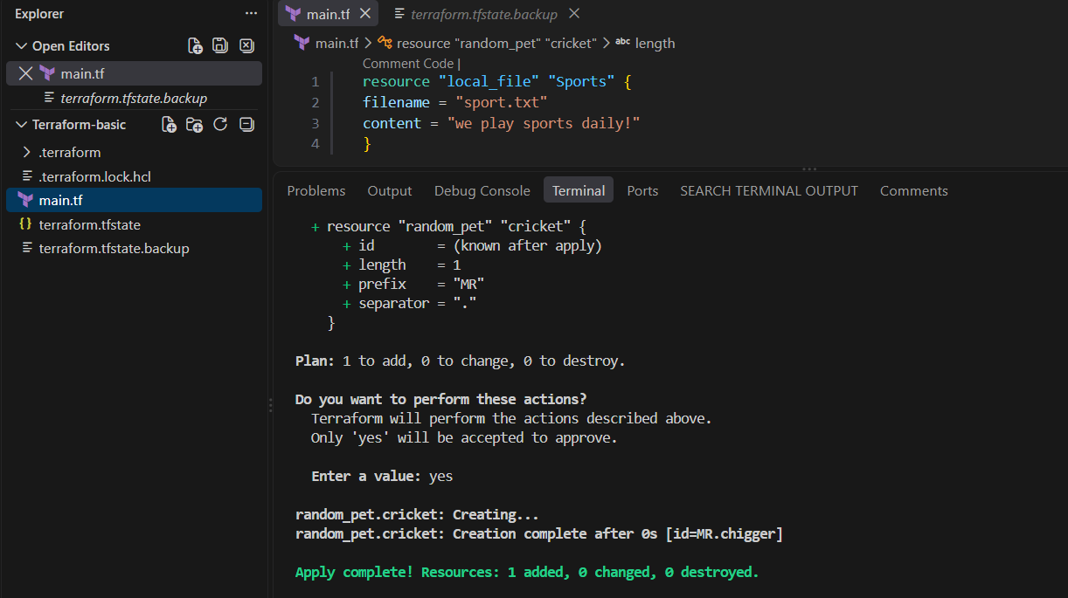

terraform.tfstate — Terraform State File
This is one of the most important Terraform files.
Purpose: terraform.tfstate stores Terraform's knowledge about the infrastructure it
manages.
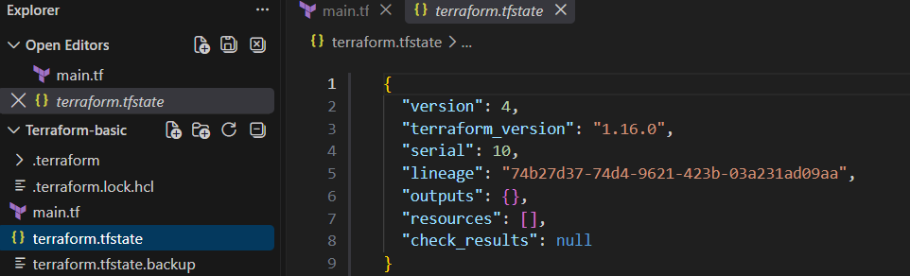

.terraform.lock.hcl — Provider Dependency Lock File
This file is created when you run:
terraform init
It records the provider versions and checksums Terraform selected.
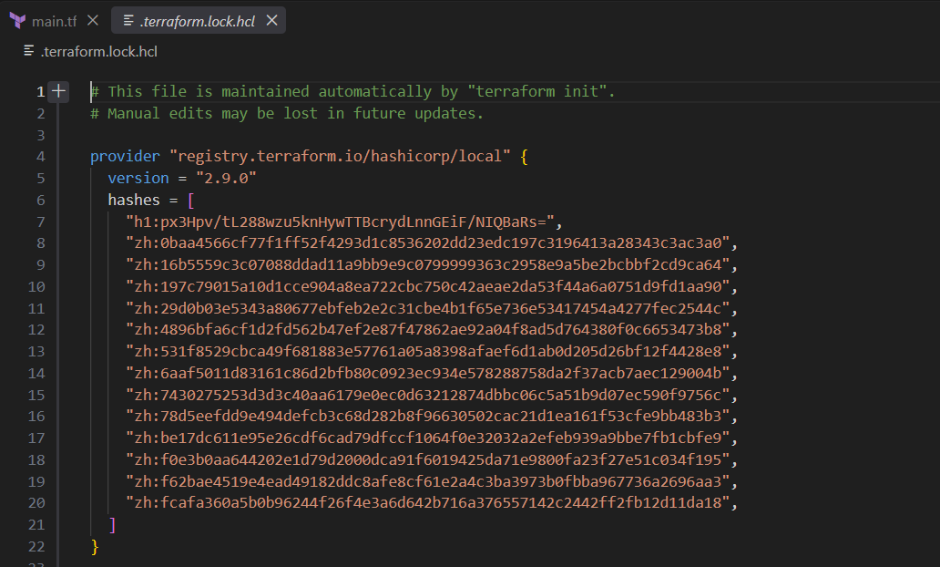

variables.tf — Input Variables
Purpose: variables.tf defines input values that can be passed into your Terraform
configuration.
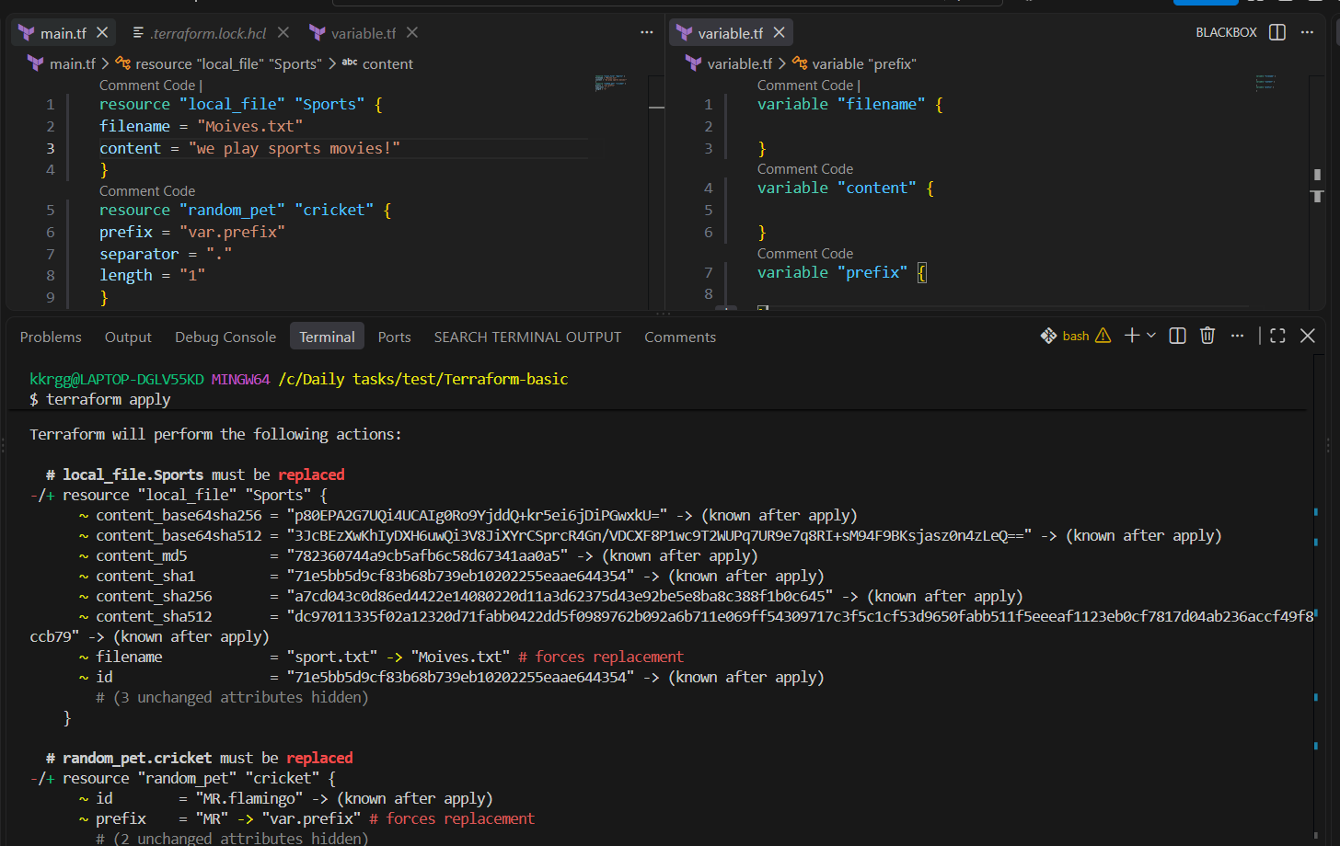
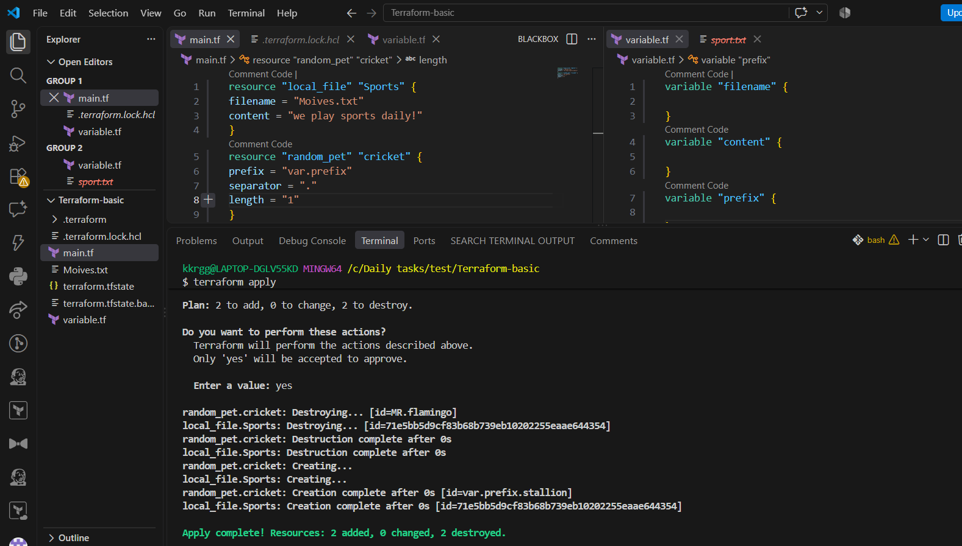
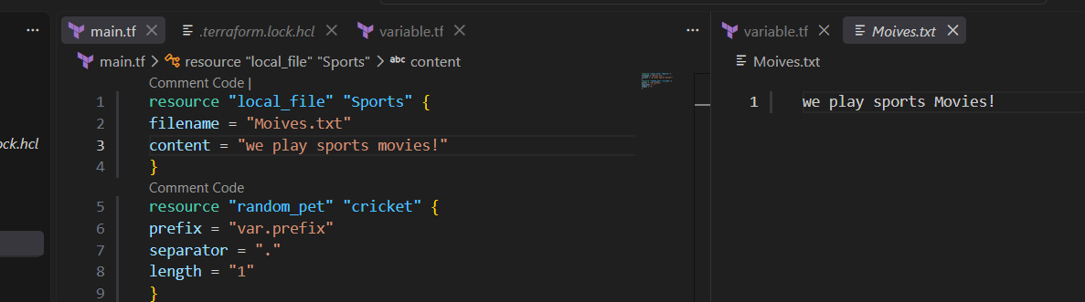
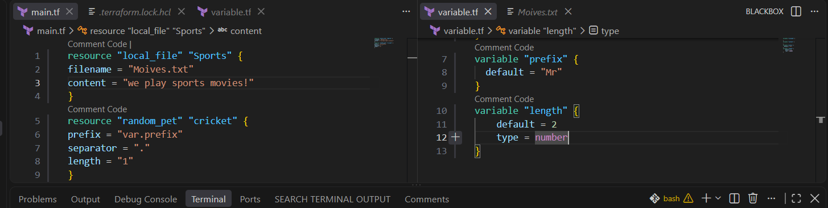
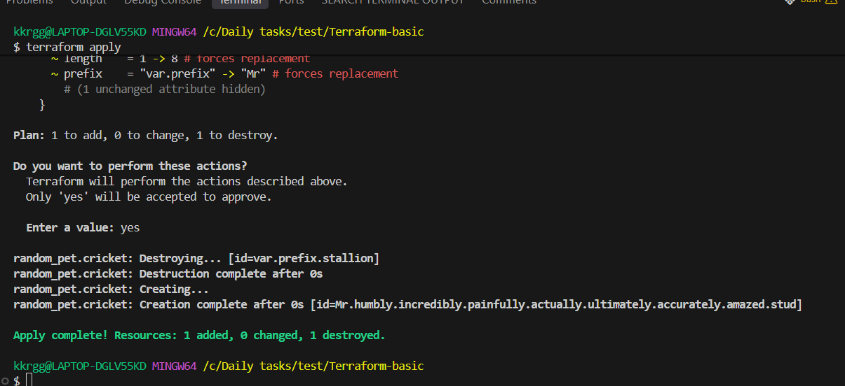

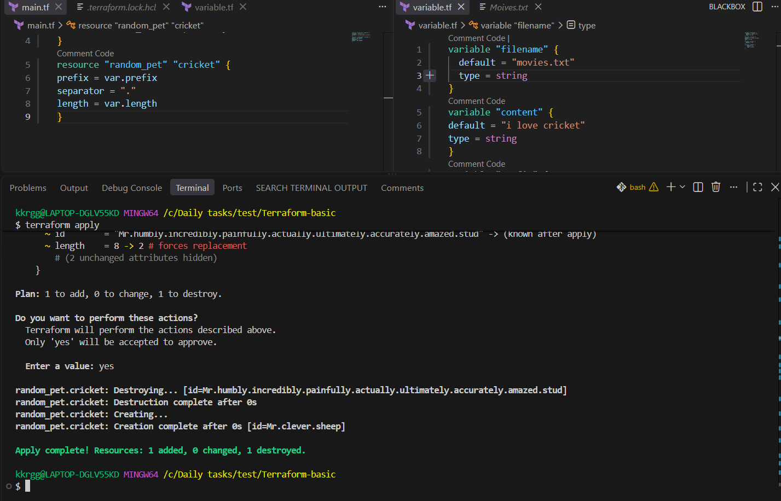

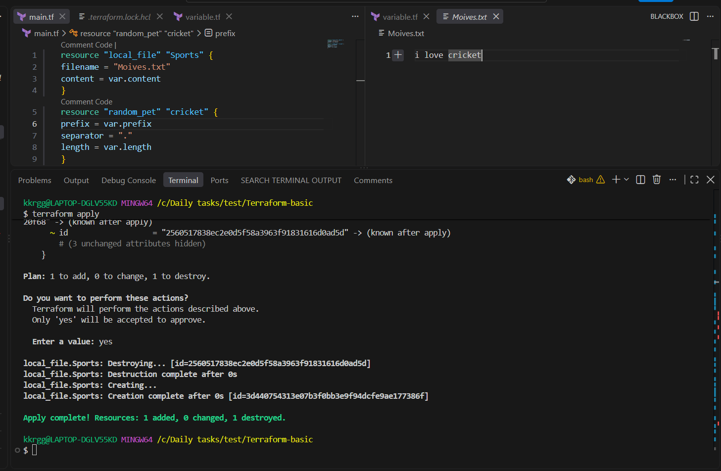
We can provides the values through terminal also with the help of “-var” command
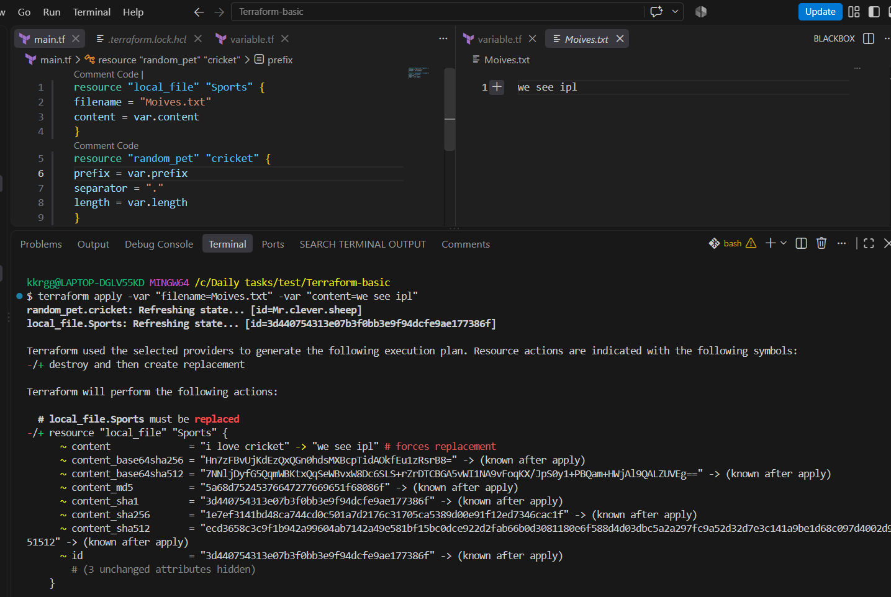
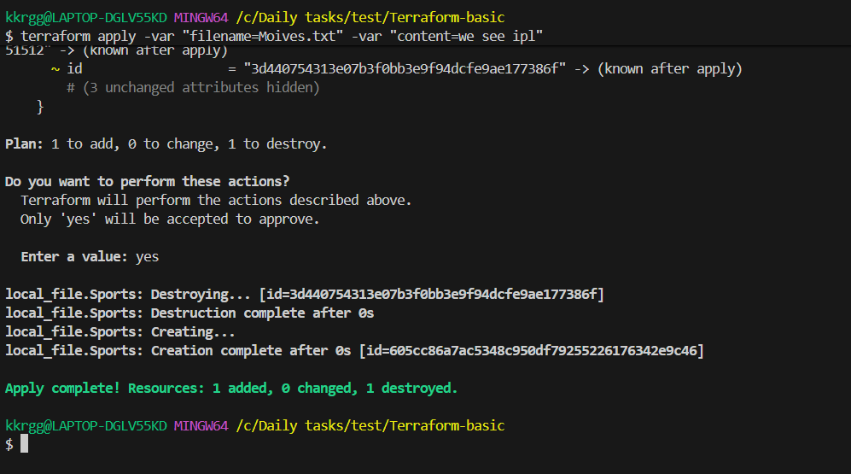

Terraform Lifecycle Rules
Terraform lifecycle rules control how Terraform creates, updates, and destroys
resources. They are written inside a lifecycle block within a resource.
There are three commonly used lifecycle rules:
1. create_before_destroy
2. prevent_destroy
3. ignore_changes
1. create_before_destroy
Normally, Terraform may destroy the old resource first and then create the new
one.
With create_before_destroy = true, Terraform creates the new resource first, then
destroys the old resource
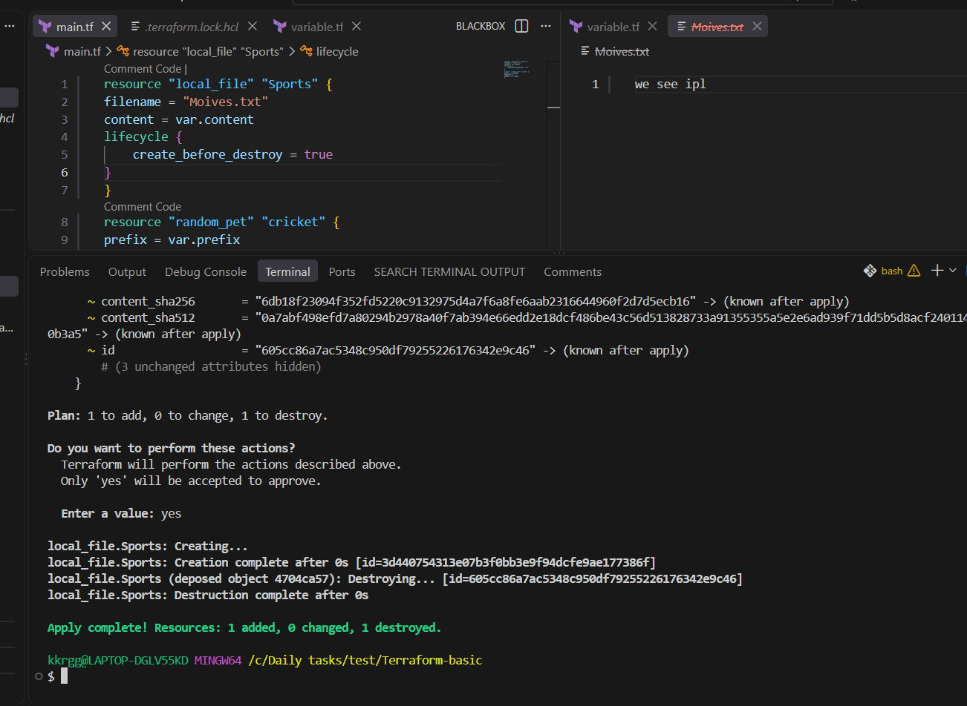

2. prevent_destroy
This prevents Terraform from destroying a resource.
When to use
Useful for critical resources such as:
• Production databases
• Important S3 buckets
• Critical infrastructure
Important: prevent_destroy is a Terraform configuration safeguard. It doesn't
protect a resource from deletion by someone using the cloud provider's console/API
directly.
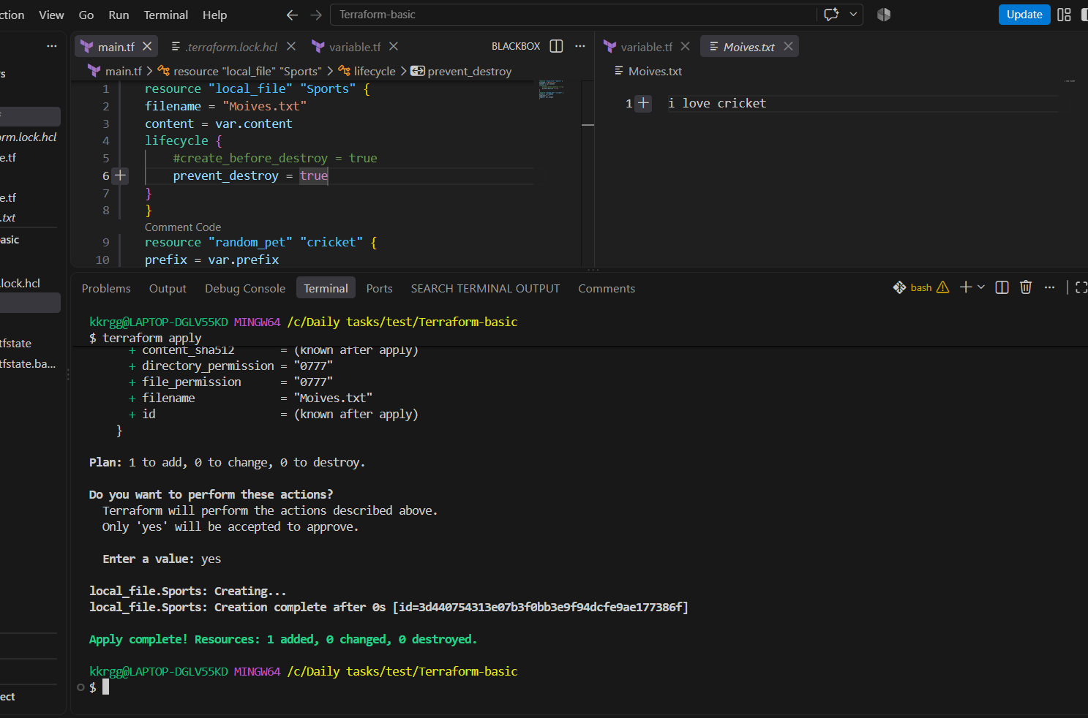

3. ignore_changes
This tells Terraform to ignore changes to specified attributes when checking for
updates.
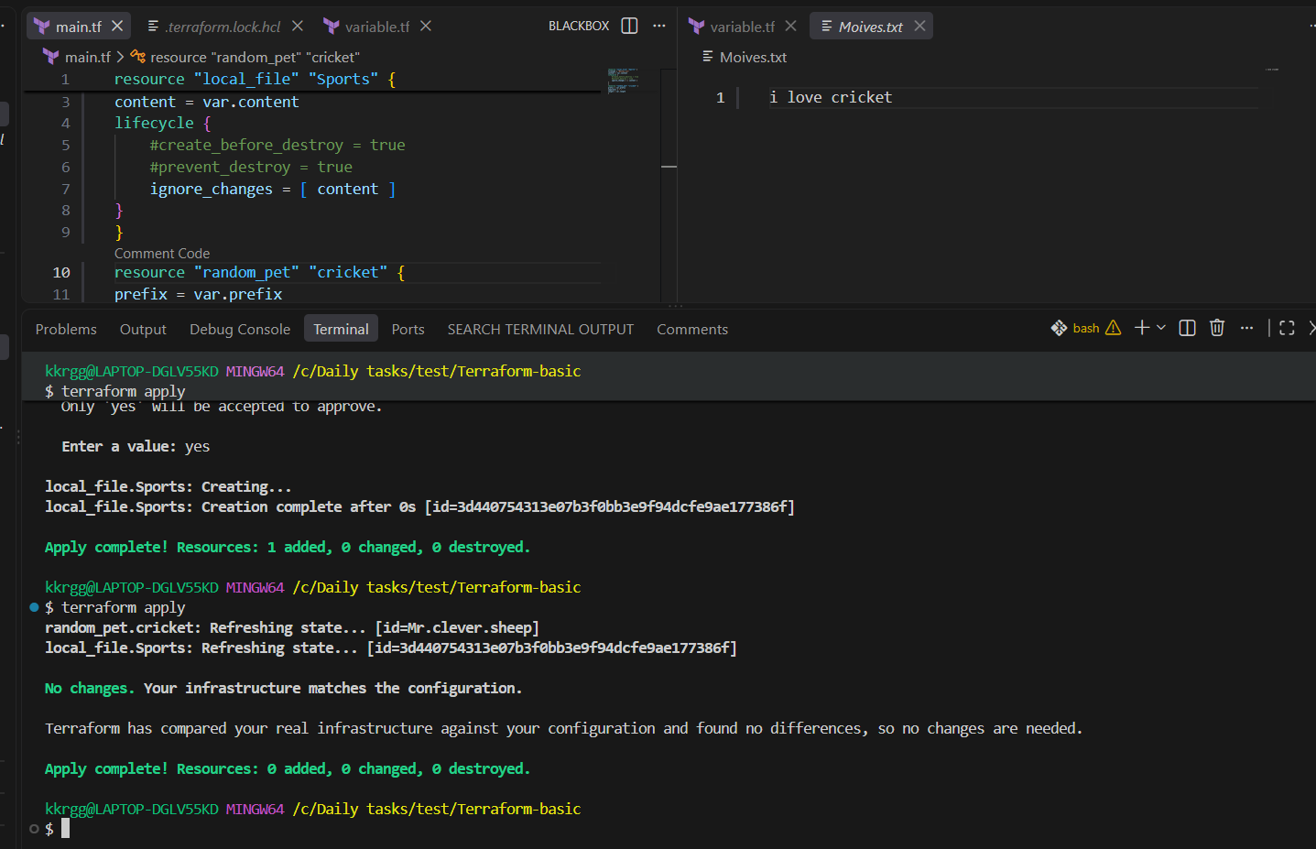
Terraform lifecycle rules control how Terraform handles resource creation,
modification, and destruction. The main lifecycle arguments are
create_before_destroy, prevent_destroy, and ignore_changes.
create_before_destroy creates the new resource before deleting the old one,
prevent_destroy prevents Terraform from destroying a resource, and ignore_changes
tells Terraform to ignore changes to specified attributes.
2). Integrate Terraform in Jenkins using the Terraform plugin.

Objective
The objective is to configure Jenkins so that Jenkins can execute Terraform commands automatically:
GitHub
↓
Jenkins
↓
Terraform Plugin
↓
terraform init
↓
terraform validate
↓
terraform plan
↓
terraform apply
↓
AWS Infrastructure
Since we already have Terraform installed on your Jenkins/EC2 environment, we'll focus on the Jenkins Terraform plugin integration.

Step 1 — Prepare Terraform project
Create a project directory:
mkdir terraform-jenkins
cd terraform-jenkins
Create:
terraform-jenkins/
├── main.tf
└── variables.tf
For a simple test, you can use a Terraform resource such as local_file.

main.tf
terraform {
required_providers {
local = {
source = "hashicorp/local"
version = "~> 2.5"
}
}

required_version = ">= 1.0"
}

provider "local" {}

resource "local_file" "example" {
filename = "${path.module}/jenkins-demo.txt"
content = "Terraform executed successfully from Jenkins!"
}
This is a good first test because it doesn't require AWS permissions.

Step 2 — Test Terraform manually first
This is important.
Go inside the Terraform project directory:
cd terraform-jenkins
Run:
terraform init
Then:
terraform validate
Then:
terraform plan
Finally:
terraform apply -auto-approve
You should see something like:
Apply complete! Resources: 1 added, 0 changed, 0 destroyed.
Check:
ls
You should have:
main.tf
jenkins-demo.txt
This confirms your Terraform code itself works before introducing Jenkins.

Step 3 — Push the Terraform project to GitHub
Inside your project:
git init
git add .
git commit -m "Add Terraform Jenkins integration"
Add your GitHub repository:
git remote add origin <YOUR_GITHUB_REPOSITORY>
Then:
git branch -M main
git push -u origin main
Your repository should contain:
terraform-jenkins/
│
├── main.tf
└── variables.tf

Step 4 — Install Terraform Plugin in Jenkins
Open Jenkins:
Jenkins
↓
Manage Jenkins
↓
Plugins
↓
Available plugins
Search:
Terraform
Install the Terraform plugin.
If Jenkins asks for a restart, restart Jenkins after installation.
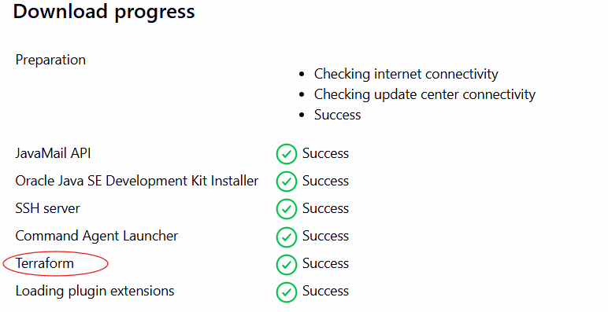

Step 5 — Configure Terraform in Jenkins
Go to:
Manage Jenkins
↓
Tools
Look for:
Terraform installations
Click:
Add Terraform
Give it a name:
Terraform
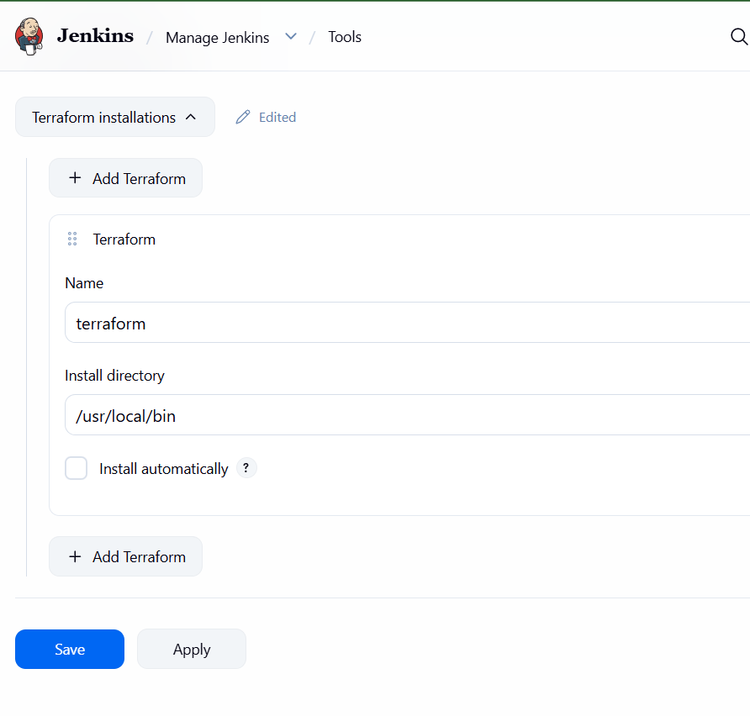

Step 6 — Create Jenkins Pipeline
Go to:
Jenkins
↓
New Item
Enter:
terraform-jenkins
Select:
Pipeline
Click OK.
Scroll to:
Pipeline
Choose:
Pipeline script
Use:
pipeline {
agent any

tools {
terraform 'terraform'
}

stages {

stage('Checkout') {
steps {
git branch: 'main',
url: 'https://github.com/YOUR_USERNAME/YOUR_REPOSITORY.git'
}
}

stage('Terraform Init') {
steps {
sh 'terraform init'
}
}

stage('Terraform Validate') {
steps {
sh 'terraform validate'
}
}

stage('Terraform Plan') {
steps {
sh 'terraform plan'
}
}

stage('Terraform Apply') {
steps {
sh 'terraform apply -auto-approve'
}
}
}
}
Replace:
YOUR_USERNAME
YOUR_REPOSITORY
with your actual GitHub repository.
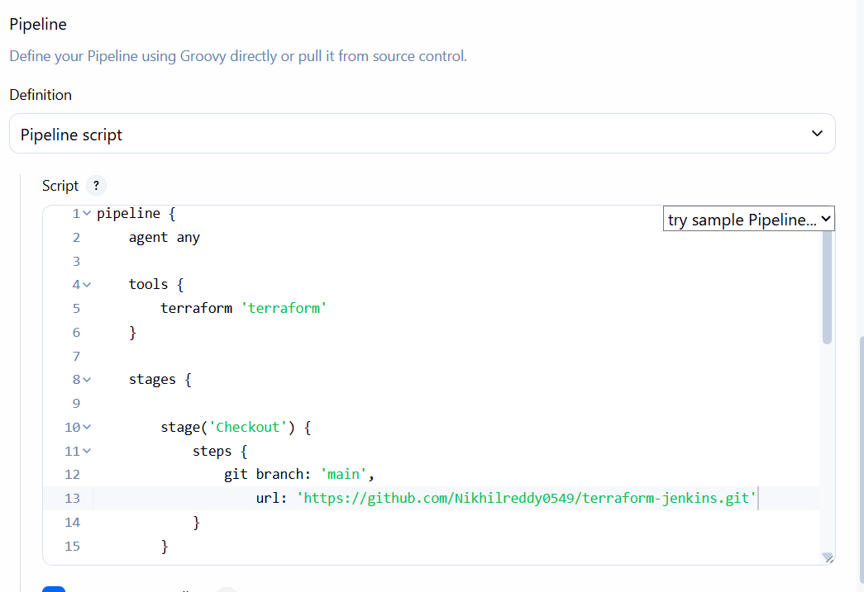

Step 7 — Build the Jenkins job
Click:
Build Now
Jenkins will execute:
Stage 1
Checkout
↓
GitHub repository

Stage 2
Terraform Init
↓
terraform init

Stage 3
Terraform Validate
↓
terraform validate

Stage 4
Terraform Plan
↓
terraform plan

Stage 5
Terraform Apply
↓
terraform apply -auto-approve

Step 8 — Check Console Output
Click the build:
Build #1
↓
Console Output
You should see:
Terraform has been successfully initialized!
Then:
Success! The configuration is valid.
Then the plan:
Plan: 1 to add, 0 to change, 0 to destroy.
Finally:
Apply complete! Resources: 1 added, 0 changed, 0 destroyed.
Your Jenkins build should finish:
Finished: SUCCESS
